FD&C dyes are organic molecules with chemical structures containing multiple carbon rings with double bonds (see Figure 3). When molecules have a series of double bonds separated by single bonds, the bonding pattern is called conjugation. This pattern of bonding results in a reduced separation between the ground state and the excited state of the electrons. The energy difference corresponds to the energy of photons in the visible region. As the amount of conjugation increases, the energy of the absorbed photon decreases. The structures and molar masses of FD&C Red 40 and Yellow 5 are shown below in Figure 7.

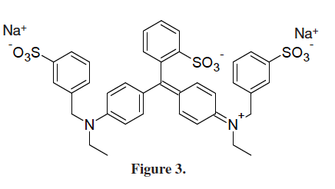
FD&C Blue 1
Molar Mass 793 g/mol

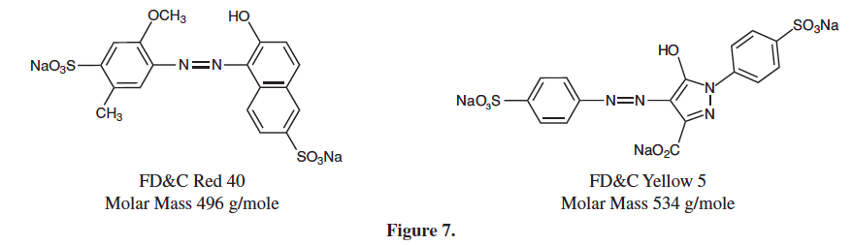

- Rank the three food dyes in order of absorption of light that is the least energetic to most energetic. Explain your ranking.

Spectrophotometric studies can be conducted on any colored compound. The transition metal group of the periodic table exhibits a wide array of different colored compounds. The complex ion tetraamminecopper(II) contains four ammonia molecules covalently bonded to a copper(II) ion. In aqueous solutions, Cu²⁺ ions will bond to four water molecules in a square planar geometry. The ion is a light blue color. The water molecules can be displaced by ammonia molecules, which are stronger Lewis bases than water. The appearance of the intense dark blue-violet color of the [Cu(NH3)4] ²⁺ ion is often used as a positive test to verify the presence of Cu²⁺ ions.

2. Write a balanced chemical equation for the reaction of copper(II) sulfate and concentrated ammonia to produce tetraamminecopper(II) sulfate.

3. [Cu(NH3)4] ²⁺ solutions exhibit a deep blue-violet color. How can you use spectrophotometry to confirm that this reaction has occurred and that the product formed is in fact tetraaminecopper(II) sulfate? Would you expect the wavelength of maximun absorbance (λ_{max}) for Cu(NH3)4²⁺ to be greater than or less than λ_{max} for Cu(H2O)6²⁺ ? Explain.

4. The electron transitions responsible for the colors of transition metal ions involve d → d transitions. Why are zinc ions colorless in aqueous solution?
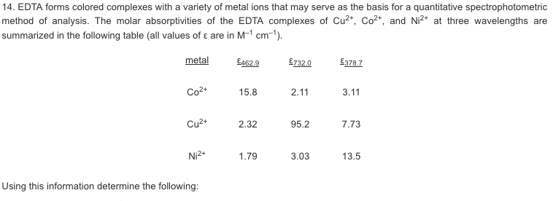
path length = 1.00 cm

- What is the concentration of the Cu²⁺ complex in a solution that has an absorbance of 0.338 at a wavelength of 732.0 nm?
- What absorbance would you expect for the solution in part (a) using a wavelength of 462.9 nm?
- Which wavelength would be the best choice for the Cu²⁺ complex? Explain.
- Make a sketch that shows the expected shape of a plot of Absorbance vs. concentration for the Cu²⁺ complex at the 732.0 nm.
- Make a sketch that shows the expected shape of a plot of Absorbance vs. wavelength for the Cu²⁺ complex.
- Which wavelength would be best for the Co²⁺ complex ?
- What is the color of the solution containing the Cu²⁺ complex ? the Co²⁺complex ?

M = metal ion
Structure of EDTA
