- Write the name of your assigned DNA base. ______________________________________
- Build a model of your assigned DNA base.
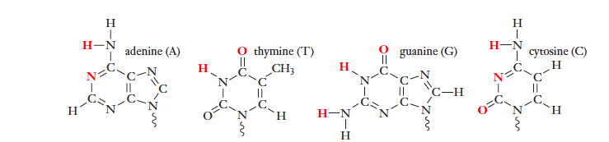

- A & T can pair together and G & C can pair together. Find a group that can pair with your base. Arrange your models to show how they fit together via hydrogen bonding.
How many hydrogen bonds are present in the A and T base pair?___________
How many hydrogen bonds are present in the G and C base pair?___________

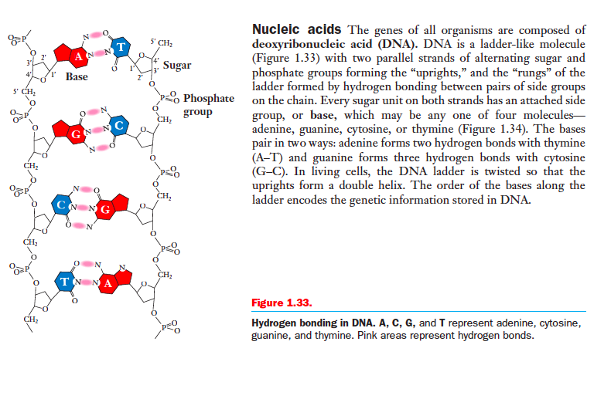

- In order to fit together to make the most stable the double helix, consider these two factors
- Effectiveness of hydrogen bonding between the two bases
- Number of rings
What do you notice about the A-T and G-C pairs with regard to these two factors?

- Try making alternative pairs, such as A-C and G-T and A-A.
Can these pairs make hydrogen bonds?________
Do these pairs fit together as effectively?__________ Explain.

6. Answer questions in “1.34 Consider This”
