Solar Cells and the Photoelectric Effect Excerpt from “How Things Work: Solar Cells” http://thetartan.org/2010/1/18/scitech/solarcells Eco-friendly solar cells convert light energy to electrical energy. ( photocredit: Wikipedia Commons)
Top of Form
Bottom of Form

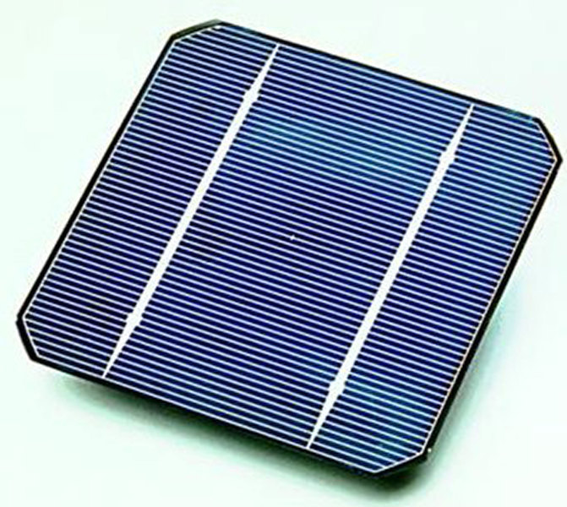
The simplest solar cell can be devised from just crystalline silicon. When light falls on the surface of the crystalline silicon, the energetic light particles — photons — transfer their energy to the electrons in the covalent bonds of the silicon atoms. Electrons can only leave the bond they are shared in if supplied with sufficient energy. Only photons that are vibrating at a “threshold frequency” or above possess enough energy to knock an electron out of its covalent bond. Any photons at frequencies less than the threshold frequency pass right through the silicon wafer without releasing any electrons. Photons with too much energy release an electron, and the excess energy is dissipated in the wafer as heat.
Releasing electrons from bonds is important because free electrons constitute the flow of electric current. The electrons that receive sufficient energy from incident photons then break free from the covalent bond and are forced to move in one direction, usually toward one electrode.
An escaping electron leaves in its place a “hole,” which simply represents the lack of an electron in a bond. These holes, which are atoms missing an electron, migrate toward the opposite electrode anti-parallel to the direction of motion of the electrons. The movement of electrons generates an electric current, which ultimately is the basis for getting power from solar cells.
For a certain solar cell made of hydrogenated amorphous silicon wafers (abbreviated Si-H), the threshold energy is 1.9 eV. (1.602 x 10 ⁻¹⁹ J = 1 eV)

- Calculate the threshold wavelength.

- In what region of the EM spectrum is this wavelength?

- Which of the following types of radiation would knock an electron from the Si-H wafer? Explain. blue light, yellow light, microwaves, UV, x-rays, radio waves

- If the incident light has a wavelength of 475 nm, determine the kinetic energy of the ejected electron in units of eV.

- How is KE related to temperature (in Kelvin)?

- If much of the energy above the threshold energy is dissipated as heat, what would happen to the temperature of the Si-H wafers?

- “Efficiency is defined as the ratio of output electric energy to the incident light energy. A silicon wafer alone produces very little electric energy, usually on the order of less than 5 percent. This efficiency can be improved by a number of methods.” Suggest strategies for improving the efficiency.
Periodic Trends: The chart below illustrates the general trends in the first ionization energy of the elements.
- Describe and explain the trend across a period. (such as period 2, Li to Ne)
Hint: effective nuclear charge

- Describe and explain the trend down a group. (such as group 8, noble gases)
Hint: shielding effect

