WS#5: Quantum Numbers, Orbitals, and Electron Configurations
Important note: Do not think of an electron as a “thing” that can be located. The electron charge is spread out in a “cloud” with regions of high charge density. The wave function describes the regions of high charge density.

www.angelo.edu/faculty/kboudrea/general/quantum_numbers/Quantum_Numbers.htm

Quantum Numbers and Atomic Orbitals
By solving the Schrödinger equation (Hψ = Eψ), we obtain a set of mathematical equations, called wave functions (ψ), which describe the probability of finding regions of high charge density at certain energy levels within an atom.
A wave function for an electron in an atom is called an atomic orbital; this atomic orbital describes a region of space in which there is a high probability of finding regions of high charge density. Energy changes within an atom are the result of an electron changing from a wave pattern with one energy to a wave pattern with a different energy (usually accompanied by the absorption or emission of a photon of light).
Each electron in an atom is described by four different quantum numbers. The first three (n, l, m_{l}) specify the particular orbital of interest, and the fourth (m_{s}) specifies how many electrons can occupy that orbital.
- Principal Quantum Number (n): n = 1, 2, 3, …, ∞
Specifies the energy of an electron and the size of the orbital (the distance from the nucleus of the peak in a radial probability distribution plot). All orbitals that have the same value of n are said to be in the same shell (level). For a hydrogen atom with n=1, the electron is in its ground state; if the electron is in the n=2 orbital, it is in an excited state. The total number of orbitals for a given n value is n².
- Angular Momentum (Secondary, Azimunthal) Quantum Number (l): l = 0, ..., n-1.
Specifies the shape of an orbital with a particular principal quantum number. The secondary quantum number divides the shells into smaller groups of orbitals called subshells (sublevels). Usually, a letter code is used to identify l to avoid confusion with n:
l | 0 | 1 | 2 | 3 | 4 | 5 | ...
Letter | s | p | d | f | g | h | ...
The subshell with n=2 and l=1 is the 2p subshell; if n=3 and l=0, it is the 3s subshell, and so on. The value of l also
has a slight effect on the energy of the subshell; the energy of the subshell increases with l (s < p < d < f).
Draw a picture to show the shape of the orbitals in each subshell (also called sublevel).

s p d (has two shapes) f (has two shapes)
- Magnetic Quantum Number (m_{l}): m_{l} = -l, ..., 0, ..., +l.
Specifies the orientation in space of an orbital of a given energy (n) and shape (l). This number divides the subshell into individual orbitals which hold the electrons; there are 2l+1 orbitals in each subshell. Thus the s subshell has only one orbital, the p subshell has three orbitals, and so on.
Draw each orbital to show the orientation about the x,y,z-axes.

p_{x} p_{y} p_{z}
Draw all 3 p orbitals together, and you get the complete p subshell.

p subshell

- Spin Quantum Number (m_{s}): m_{s} = +½ or -½.
Specifies the orientation of the spin axis of an electron. An electron can spin in only one of two directions (sometimes called up and down).
The Pauli exclusion principle (Wolfgang Pauli, Nobel Prize 1945) states that no two electrons in the same atom can have identical values for all four of their quantum numbers. What this means is that no more than two electrons can occupy the same orbital, and that two electrons in the same orbital must have opposite spins.
Because an electron spins, it creates a magnetic field, which can be oriented in one of two directions. For two electrons in the same orbital, the spins must be opposite to each other; the spins are said to be paired. These substances are not attracted to magnets and are said to be diamagnetic. Atoms with more electrons that spin in one direction than another contain unpaired electrons. These substances are weakly attracted to magnets and are said to be paramagnetic.

Table of Allowed Quantum Numbers
n | l | m_{l} | Number of  orbitals | Orbital  Name | Number of  electrons
1 | 0 | 0 | 1 | 1s | 2
2 | 0 | 0 | 1 | 2s | 2
 | 1 | -1, 0, +1 | 3 | 2p | 6
3 | 0 | 0 | 1 | 3s | 2
 | 1 | -1, 0, +1 | 3 | 3p | 6
 | 2 | -2, -1, 0, +1, +2 | 5 | 3d | 10
4 | 0 | 0 | 1 | 4s | 2
 | 1 | -1, 0, +1 | 3 | 4p | 6
 | 2 | -2, -1, 0, +1, +2 | 5 | 4d | 10
 | 3 | -3, -2, -1, 0, +1, +2, +3 | 7 | 4f | 14

Writing Electron Configurations
The distribution of electrons among the orbitals of an atom is called the electron configuration. The electrons are filled in according to a scheme known as the Aufbau principle ("building-up"), which corresponds (for the most part) to increasing energy of the subshells:
1s, 2s, 2p, 3s, 3p, 4s, 3d, 4p, 5s, 4d, 5p, 6s, 4f, 5d, 6p, 7s, 5f
It is not necessary to memorize this listing, because the order in which the electrons are filled in can be read from the periodic table in the following fashion:

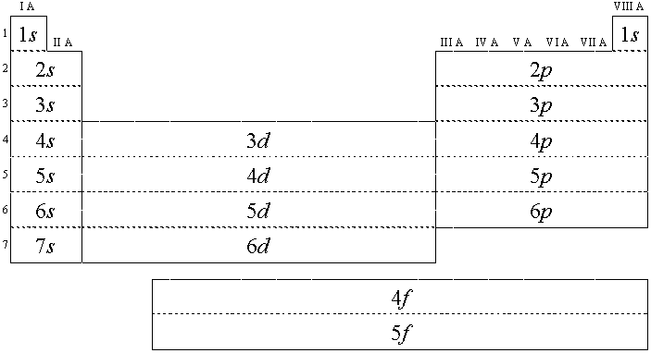
Or, to summarize:
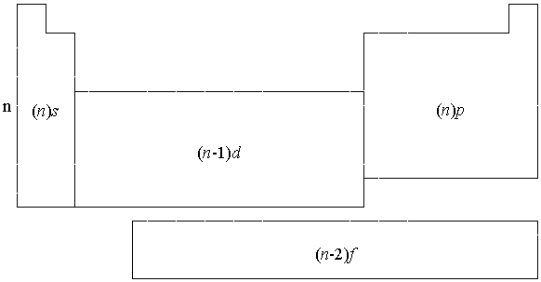

1. In electron configurations, write in the orbitals that are occupied by electrons, followed by a superscript to indicate how many electrons are in the set of orbitals (e.g., H 1s¹)
a) Write the electron configuration for the following elements:
Ne _____________________________________________________________________________
Ar_____________________________________________________________________________
Li_____________________________________________________________________________
Na_____________________________________________________________________________
K_____________________________________________________________________________
N_____________________________________________________________________________
P_____________________________________________________________________________
As_____________________________________________________________________________
b) What patterns do you see?

c) Circle the part of the electron configuration that represents the valence electrons.
d) Put a box around the core electrons. The core electrons in the s & p subshells correspond to the electron configuration of a noble gas! You may use the noble gas abbreviation. For example, the electron configuration for Na can be written as [Ne]3s¹
2. Another way to indicate the placement of electrons is an orbital diagram, in which each orbital is represented by a square (or circle), and the electrons as arrows pointing up or down (indicating the electron spin). When electrons are placed in a set of orbitals of equal energy (called degenerate orbitals), they are spread out as much as possible to give as few paired electrons as possible (Hund's rule).
a) Draw in the arrows to show the placement of electrons for the element P.
☐ ☐ ☐☐☐ ☐ ☐☐☐
1s 2s 2p 3s 3p
How many unpaired electrons? ______ Is this element diamagnetic or paramagnetic?________ How can you tell?

b) Make an orbital box diagram for the element Ca.

How many unpaired electrons? ______ Is this element diamagnetic or paramagnetic?________ How can you tell?

You may also arrange the orbital box diagram like an energy diagram as shown below. Label each sublevel.

☐

☐☐☐
☐
⬆
Energy ☐☐☐
☐
☐

